  FAKE NEWS CLASSIFICATION WITH AI  A machine learning technique for detecting fake news | Kenneth Nyangweso  KENNETH NYANGWESO  DATA SCIENTIST | MACHINE LEARNING ENGINEER

FAKE NEWS CLASSIFICATION WITH NLP

BUSINESS UNDERSTANDING:

Misinformation is spreading faster than ever on social media and news websites, affecting public opinion, politics, and societal trust. Manual verification of news is slow, expensive, and error-prone. This project builds an automated system to classify news articles as fake or real, helping users and organizations identify misinformation reliably.

PROJECT OVERVIEW:

This project leverages Natural Language Processing (NLP) and transformer-based models for fake news detection. The workflow includes:
- Data Understanding : Understanding the dataset in-terms of column , row, and statistical distribution
- Data Cleaning and Preprocessing : cleaning, tokenization, handling very large news articles (multi-paragraph).
- Exploratory Data Analysis (EDA) : understanding text distributions, class balance, and article lengths.
- Modeling : Training multiple models i.e machine learning models, neural networks and transformer-based models
- Evaluation : Evaluate model performance using classifications metrics such accuracy and F1-Score
- Deployment : Using API servers for real-time predictions

PROBLEM STATEMENT:

Manual verification of news is inefficient and error-prone. Users and organizations need an automated, scalable method to detect fake news accurately. The challenge is detecting both short and long news articles while providing confidence scores.

OBJECTIVES:

- Compare multiple models (Naive Bayes, SVM, LSTM, BiLSTM, Distil BERT) for fake news classification.
- Train models to handle large, multi-paragraph news articles.
- Build a Fast API backend for serving predictions.
- Create a simple React frontend for user interaction.
- Evaluate performance using accuracy, F1-score, and prediction confidence.

METRICS OF SUCCESS:

- Accuracy ≥ 95% for transformer-based models
- F1-score ≥ 95% for high reliability
- Correctly classifying multi-paragraph news articles
- Prediction latency < 1 second per article
- User-friendly API and frontend interface

DATA UNDERSTANDING:

The dataset was sourced from the Kaggle website. It is called WELFake which classifies international news as either real or fake
The dataset consists of 72,134 entries and 4 columns. The column names are as follows:
- Unnamed - ID
- Title – Title of the news article
- Text – The news article itself
- Label – Classification indication in integer form where 0 is fake and 1 is real

DATA CLEANING AND PREPROCESSING:

In this phase I begun cleaning of the dataset by:
- Dropping the Unnamed column as it was not necessary for the analysis
- Handling missing values by dropping all rows with missing values
- Combined the title column and text column as one for easier analysis and more insights
- Text cleaning i.e tokenization, lemmatization, removal of stop words and removal of punctuation signs and special characters
Text cleaning definitions :
- Tokenizaton – Process of splitting texts into smaller units called tokens
- Stop words – Words that occur frequently in a language and do not carry much meaning on their own examples are ‘a’, ‘the’ etc.
- Lemmatization – It is the processes of reducing a word to its base form for instance studying to study

Preprocessing :

The techniques used were:
- Term Frequency – Inverse Document Frequency (TF-IDF) – This a combination of two individual metrics TF and IDF. TF – Is a measure of how frequently a term appears in a document and IDF is a measure of rare a common term occurs in the entire corpus
- Auto Tokenizer – Is a utility in Hugging Face Transformers Library that automatically loads the correct tokenizer for any pre-trained model without the needing to know the tokenizer class.

EXPLORATORY DATA ANALYSIS:

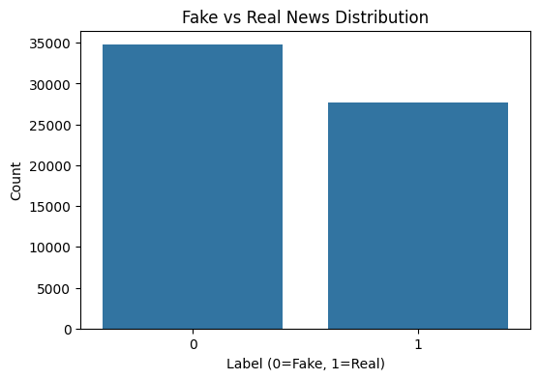

Observations:
- Imbalanced Classes: "Fake News" (0) significantly outweighs "Real News" (1).
- Bias Risk: Models might naturally lean toward predicting "Fake" due to the higher frequency.
- Metrics: Accuracy may be misleading; prioritize F1-Score or Precision-Recall to account for the gap.

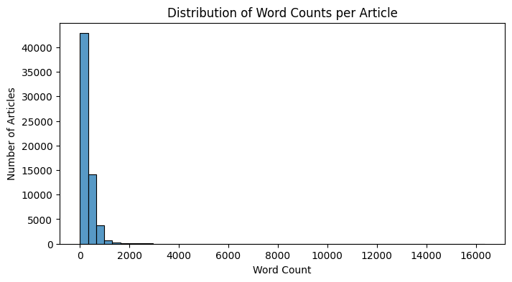

Observations:
- Skewed Distribution: Highly right-skewed; the vast majority of articles are short, concentrated under 1,000 words.
- Outliers: A small number of extreme outliers extend beyond 16,000 words.

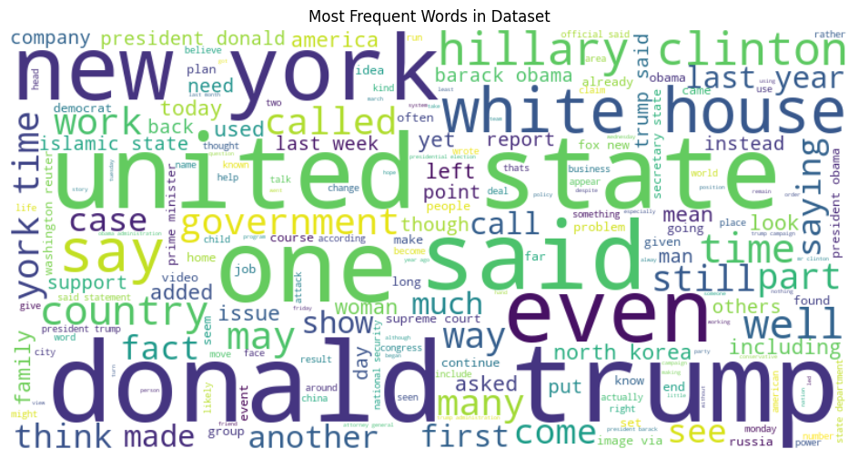

Observations:
- Political Focus: Both categories are dominated by US politics, specifically terms like "Donald Trump," "Hillary Clinton," and "White House."
- Neutral Language: The most frequent words across both are functional terms like "said," "one," and "state," suggesting similar reporting styles on the surface.

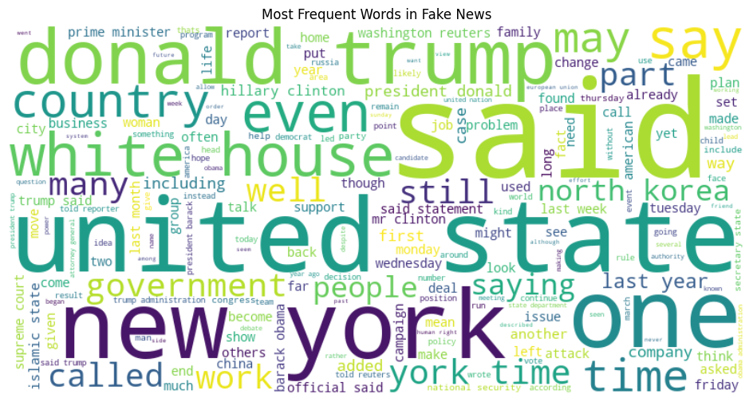

Observations:

- Dominant Terms: The largest words, indicating the highest frequency, include "donald," "trump," "said," "one," "new," and "york".
- Political Focus: Many high-frequency terms are related to United States politics, such as "hillary clinton," "white house," "obama," "government," and "united state".

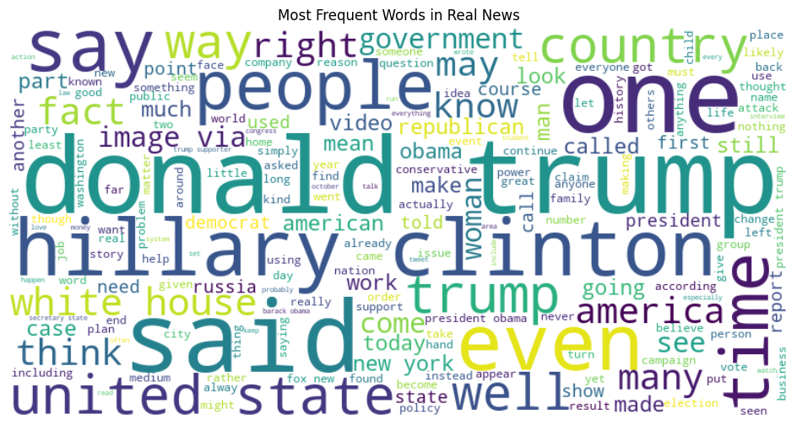

Observations:
- Central Figures & Entities: The most prominent names are "donald trump," "clinton," "hillary," and "obama". Other major entities include the "white house," "republican," and "democrat."
- Geographic Focus: Frequent references to "united state," "new york," and "america" indicate that this dataset is primarily focused on U.S. national and local reporting.

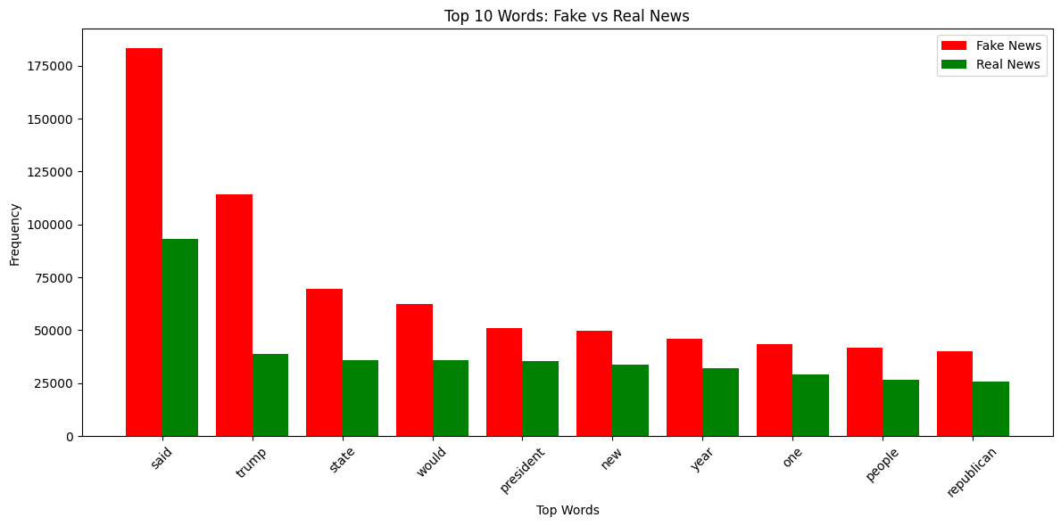

Observations:

Higher Volume in Fake News: The word "said" appears nearly twice as often in fake news (~180k) compared to real news (~95k).
Consistent Ranking: The top keywords (Trump, state, president) follow a similar frequency pattern in both classes, though fake news consistently shows higher raw counts across all top 10 words.

MODELING:

For the modeling phase I used numerous models i.e machine learning models, neural networks and HuggingFace transformers

- Machine Learning Models:
  - Naïve Bayes
  - Support Vector Machine
- Neural Networks:
  - Long Short-Term Memory (LSTM)
  - Bi-directional Long Short-Term Memory (Bi-LSTM)

- HuggingFace Transformer:
- Distil BERT

EVALUATION:
For this project the evaluation metrics used are:
- Accuracy
- F1-score
For the visual I used:
- Confusion Matrix
- ROC-AUC Curve

Results:
MODEL/METRIC | Naïve Bayes | SVM | LSTM | BiLSTM | Distil BERT
Accuracy (%) | 85 | 96 | 91 | 96 | 98
F1-Score(%) | 84 | 96 | 90 | 95 | 98

Model Performance Ranking :
- Best Overall: DistilBERT leads with 98% in both metrics, showing the superior power of transformer-based contextual learning.
- High Efficiency: SVM and BiLSTM are tied for second at 96% accuracy, though SVM maintains a slightly higher F1-score than BiLSTM.
- Weakest Link: Naïve Bayes is the lowest performer (85%), struggling to capture complex patterns compared to deep learning methods.

Key Comparisons
- Architectural Impact: The BiLSTM (96%) significantly outperforms the standard LSTM (91%), proving that reading text in both directions is crucial for news classification.
- Classical vs. Deep Learning: The SVM (96%) surprisingly matches the more complex BiLSTM, suggesting it is a highly efficient, lower-resource alternative for this specific dataset.
- Metric Stability: Across all models, Accuracy and F1-Score are nearly identical (within 1%), indicating that the models are performing consistently across both "Real" and "Fake" classes without heavy bias.

Confusion Matrices:
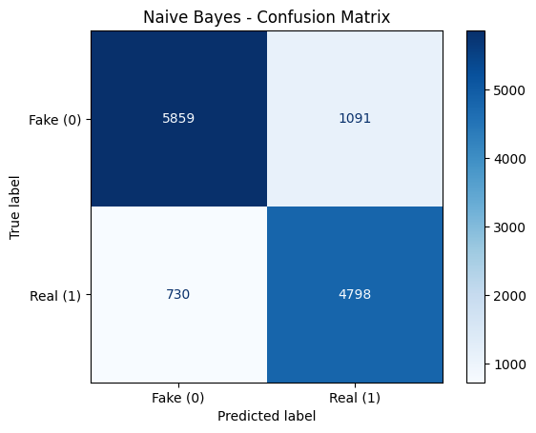

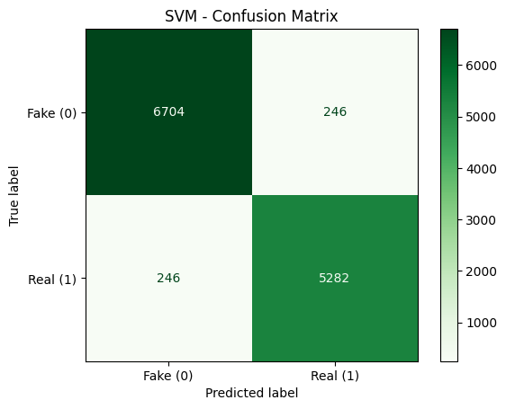

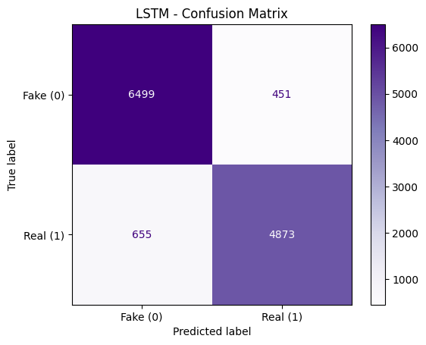

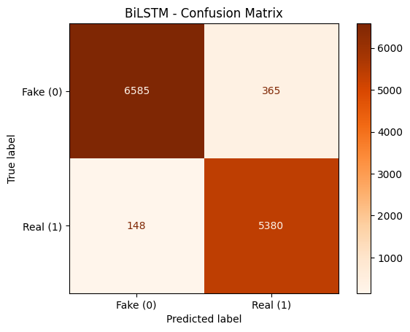

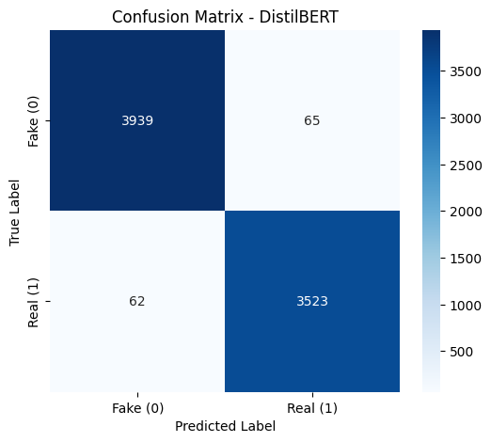

Insights:

- Naive Bayes: High number of False Positives (1,091); weakest performer overall with the most misclassifications.
- SVM: Significant improvement over Naive Bayes, achieving a balanced error rate with exactly 246 misclassifications for both classes.
- LSTM: Shows a slight struggle with False Negatives (655), indicating it occasionally misses real news more than fake news.
- BiLSTM: Highly effective; significantly reduces errors compared to the standard LSTM, with only 148 False Negatives.
- DistilBERT: The top performer; achieves near-perfect classification with only 65 False Positives and 62 False Negatives.

DEPLOYMENT:

Overview
This document describes the steps to deploy the Fake News Classification system locally. The system consists of:
- Backend: FastAPI server with the best performing model DistilBERT.
- Frontend: React application that interacts with the backend to classify user-provided news articles.
The deployment focuses on a local setup, avoiding cloud services for simplicity.

2. Prerequisites
Before deploying, ensure the following software is installed:
- Python 3.11 (or compatible version)
- Node.js and npm (for frontend)
- Virtual environment tools (venv or conda)
- Git (optional, if cloning from repository)

- The backend hosts trained models and provides endpoints for classification requests.
- The frontend is a user interface that submits news text and displays predictions and confidence scores.
- Users can run the system locally without cloud services, allowing full control over the environment.
- Long, multi-paragraph articles achieve higher accuracy, while short articles can optionally leverage SVM for better predictions.

Architecture Diagram
Description:
- Input Layer: User submits news article via frontend.
- Backend Layer: Receives the input, passes through preprocessing, and selects the appropriate model.
- Model Layer: Performs prediction using trained models (Naive Bayes, SVM, LSTM, BiLSTM, DistilBERT).
- Output Layer: Returns prediction label (Fake/Real) and confidence score to frontend.

CONCLUSIONS:

- DistilBERT achieves the highest accuracy and F1-score, particularly on multi-paragraph news articles.
- Traditional ML models (SVM, Naive Bayes) are useful for short articles and quick
predictions.

- DistilBERT was trained and evaluated on full-length news articles (some with 10+ paragraphs). Short texts may lead to lower confidence or misclassification because transformer-based models are optimized for richer context.

- Proper preprocessing and article length consideration significantly improve performance.

RECOMMENDATIONS:

- Use DistilBERT for production as primary model; fall back to SVM for very short articles.
- Deploy behind a server if you later want web access. Could use Docker, Railway, or Render once cloud knowledge is comfortable.
- Add caching for repeated predictions on large articles to reduce latency.
- Extend dataset with more varied short and long articles to improve generalization.
- Frontend UI improvements: allow pasting large text, provide scrollable textarea for multi-paragraph input.

PROJECT OUTCOMES AND RESULTS:

